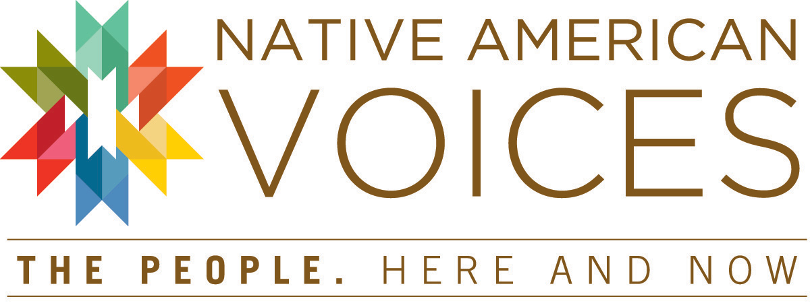
Principal Contributors to the Exhibition
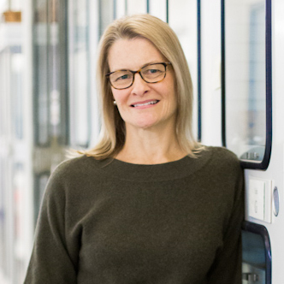
Lucy Fowler Williams, Ph.D., lead curator of the Native American Voices exhibition, is Associate Curator and Senior Keeper of the American Collections at the Penn Museum, where she has worked for 23 years. A cultural anthropologist, her research interests include issues surrounding Native American identity, material culture, Pueblo textiles, and representation. She has received grants and fellowships from the National Endowment of the Arts, the Institute of Museum and Library Services, the School for Advanced Research, and the Penn Museum. Her recent projects include the creation of the Penn Museum’s Louis Shotridge Digital Archive.
For Dr. Williams, this exhibition, years in the making, has been a richly collaborative process with input from more than 80 Native American contributors living and working across the United States and Canada, including four key advisors noted below:
Exhibition Content Advisors
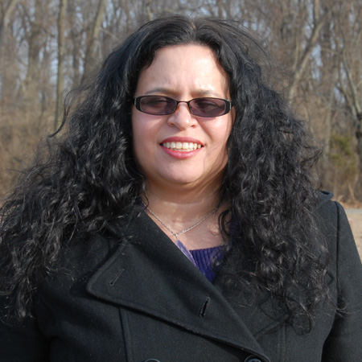
Tina Pierce Fragoso is an enrolled member of the Nanticoke Lenni-Lenape Tribe of Bridgeton, New Jersey, and Assistant Director of Equity and Excellence,
Coordinator of Native American Recruitment, at the University of Pennsylvania. An active community member who has helped restore her tribal history, Fragoso holds degrees in anthropology from Princeton and Stanford Universities. As part of Penn Admissions, she has the opportunity to recruit Native American students. Ms. Fragoso generously served as a leading advisor on the Native American Voices exhibition, and contributed an essay about her work in support of Native American undergraduate education for the exhibition’s special edition of Expedition Magazine (Winter 2013).

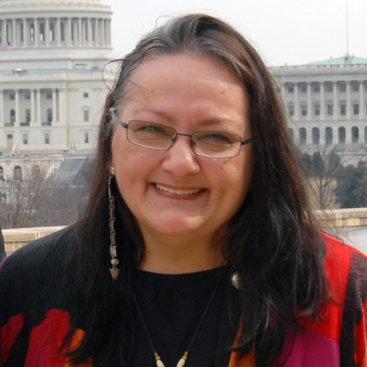
Suzan Shown Harjo (Cheyenne & Hodulgee Muscogee) is a poet, writer, lecturer, curator and policy advocate who has helped Native Peoples to recover more than one million acres of land. She has developed key laws in four decades to protect and promote Native nations, sovereignty, cultures, arts, languages, religious freedom, sacred places, repatriation, and the National Museum of the American Indian (NMAI) Act. She is President of The Morning Star Institute, a national Native rights organization founded in 1984 for Native Peoples’ traditional and cultural advocacy, arts promotion and research. She is Guest Curator and General Editor of the Smithsonian NMAI’s Treaties exhibition and book (September 2014). The first Native woman to receive an Honorary Doctorate of Humanities degree from the Institute of American Indian Arts (2011), she was the first Vine Deloria, Jr. Distinguished Indigenous Scholar (University of Arizona, 2008), the first person awarded back-to-back residencies at the School for Advanced Research (2004 Poetry Fellow and Summer Scholar), and the first Native woman Montgomery Fellow (Dartmouth, 1992). Dr. Harjo has generously served as a leading advisor on the Native American Voices exhibition, and her essay Sacred Places: Threatened and Damaged is featured in the exhibition’s special edition of Expedition Magazine (Winter 2013).

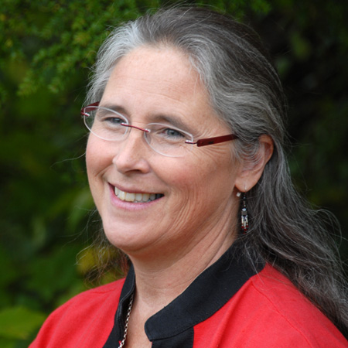
Teri Rofkar is a Tlingit fiber artist from Sitka, Alaska and a member of the T’akdeintaan [Raven] Clan. A National Endowment of the Arts National Heritage Fellow (2009), Ms. Rofkar is the recipient of numerous awards, honors, and fellowships for her textile arts from, among other entities, the Rasmuson Foundation (2009), US Artists (2006), and The Governor’s Award for Alaska Native Art (2004). Rofkar was also a finalist in 2004 for the Buffet Award in Indigenous Leadership. She is an active teacher and has conducted numerous workshops in and outside of Alaska for the National Museum of the American Indian, the Sitka School District, the Penn Museum, and the Alaska Native Heritage center, among others. Her work has been installed throughout Alaska in Anchorage, Cordova, Fairbanks, Kechikan, Sitka, and in Denver, New York, Philadelphia, Portland, Seattle, and Vancouver, BC. A Research Associate of the Penn Museum, Ms. Rofkar has studied its Tlingit collections on numerous occasions and the Penn Museum holds two pieces of her work in its collection. Rofkar has generously served as an advisor and contributor to the Native American Voices exhibition.

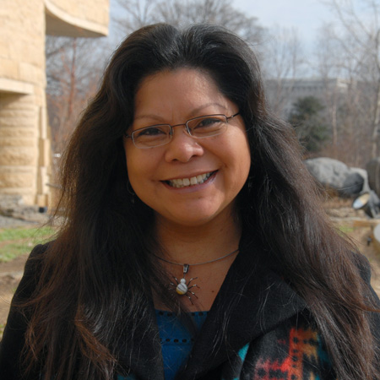
Patty Talahongva is a journalist who works in all platforms of the media: television, radio, newspapers, magazines and websites. In her 30 year career, she has covered a range of topics from Native arts to education, health, and politics. She is Hopi from Sichomovi village located on First Mesa in northeastern Arizona. She directed and produced a video-documentary about the American Indian Code Talkers in WWII for the Smithsonian’s National Museum of the American Indian in 2006, and several other programs that have aired on PBS and HBO. She is an active volunteer and a founding member of the Hopi Education Endowment Fund, a past president of the Native American Journalists Association, and a member of Unity: Journalists of Color. Ms. Talahongva has served generously as a leading advisor on the Native American Voices exhibition. As part of this work, she and her film-crew co-produced 5 short video documentaries for the exhibition with Lucy Fowler Williams in 2010, portions of which are included in the exhibition. Her essay Being Hopi is featured in the related special edition of Expedition Magazine (Winter 2013).
The exhibition would not have been possible without the following contributors from Native American communities: Marcus Amerman, Choctaw; Joseph (Woody) Aguilar, San Ildefonso Pueblo; Denise Bright Dove Ashton-Dunkley, Nanticoke Lenni-Lenape; Mary Bordeaux, M.A., Lakota; Margaret M. Bruchac, Ph.D., Abenaki; the Chickasaw Nation; Cippy Crazy Horse, Cochiti Pueblo; Thosh Collins, Salt River Pima; Stephen Conaway, Nanticoke Lenni-Lenape; Tartuilnguq Sophie Evan, Yup'ik; Ann Noe Dapice, Ph.D., Delaware/Cherokee; Melissa Darden, Chitimacha; Nora Dauenhauer, Tlingit; Richard Dauenhauer, Ph.D.; Eastern Band of Cherokee Indians; John Echohawk, J.D., Pawnee; Daniel Fragoso, Nanticoke Lenni-Lenape; Lewis Fragoso, Nanticoke Lenni-Lenape; Cliff Fragua, Jemez Pueblo; Nicholas Galanin, M.F.A, Tlingit/Aleut; Diane Glancy, M.A., Cherokee; Isabel Gonzales, San Ildefonso/Jemez Pueblos; Rayna Green, Ph.D., Cherokee; Larraine Gregg, Nanticoke Lenni-Lenape; Chief Mark Gould, Nanticoke Lenni-Lenape; Harry W. Gould, Nanticoke Lenni-Lenape; L. Buddy Gwin, J.D., Mandan; Sven Haakanson, Jr., Ph.D., Alutiiq-Sugpiat; Richard W. Hill, Sr., Tuscarora; Jerry Ingram, Choctaw/Cherokee; Vanessa Iyua, Diné; Harold Jacobs, Tlingit; Ansley Jemison, Seneca; John F.C. Johnson, Chugach; Tommy Joseph, Tlingit; Caroline Kee, Choctaw; Doug Kiel, Ph.D., Oneida of Wisconsin; Keevin Lewis, Diné; Janet and James Littlecrow, Otoe-Missouria; Oren Lyons, Onondaga-Seneca; Rebecca Lyon, Alutiiq/Athabascan; Stephanie Mach, M.A., Diné; Bryan McKinley Jones Brayboy, Ph.D., Lumbee-Cheraw; Chuck Miller, Tlingit; Duncan Munson, Nanticoke Lenni-Lenape; Lesley Munson, Nanticoke Lenni-Lenape; the Nanticoke Lenni-Lenape Tribe of Bridgeton, NJ; Dolly Naranjo Neikrug, Santa Clara Pueblo; Reverend John Norwood, Nanticoke Lenni-Lenape; Natives at Penn; Arwen Nutall, M.A., Four Winds Cherokee/Louisiana Cherokee Confederacy; Simon Ortiz, Acoma Pueblo; Tanis Parentengru, Metis and Cree; Christy Pierce, Nanticoke Lenni-Lenape; Edith Little Swallow Pierce, Nanticoke Lenni-Lenape; Lewis Pierce Sr., Nanticoke Lenni-Lenape; Clarissa Rizal, MFA, Tlingit; Dextra Quotskuyva, Hopi-Tewa; Rachael Ridgway, Nanticoke Lenni-Lenape; Melanie Ridgway, Nanticoke Lenni-Lenape; Samantha Ridgway, Nanticoke Lenni-Lenape; Urie Ridgeway, Nanticoke Lenni-Lenape; Governor George Rivera, Pojoaque Pueblo; Clarissa Rizal, Tlingit; Teri Rofkar, Tlingit; Diego Romero, Cochiti Pueblo; Patricia Rosello, Nanticoke Lenni-Lenape; Gary S. Roybal, San Ildefonso Pueblo; Ramoncita C. Sandoval, Ohkay Owingeh; Sealaska Heritage Institute; Alqaq Katherine Small, Yup'ik; Sherrie Smith-Ferri, Ph.D., Dry Creek Pomo/Bodega May Miwok; C. Maxx Stevens, M.F.A., Seminole; Rennard Strickland, J.D., Osage/Cherokee; Roxanne Swentzell, Santa Clara Pueblo; Shawn Tafoya, Santa Clara Pueblo; Anton Treuer, Ph.D., Ojibwe; Denise Waterman Tsadeyohdi, Onondaga; Lance Magpie White, Oglala Lakota; Gerald Vizenor, Ph.D., Anishinaabe; Joe Watkins, Ph.D., Choctaw; Emmie Whitehorse, M.A., Diné; Michael Wilcox, Ph.D., Yuma/Choctaw; Taylor Williams, Nanticoke Lenni-Lenape; Vince Williams, Ph.D., Lakota; Rico Worl, Tlingit; Jolene Yazzie, Diné; Curtis Zunigha, Delaware Tribe of Indians in Oklahoma.

American Section staff members William Wierzbowski, Associate Keeper of the American Collections, and Stacey Espenlaub, Kamensky NAGPRA Coordinator, contributed to the content development and implementation of the exhibition. Several student interns have also assisted in the development of the exhibition including Tyler Ebeling, Caroline Kee (Choctaw), Carolyn Moneymaker(Cherokee), Deven Parker, Sophia Perlman, and Alexander Tickle.
Image credits: Top photo by Scott Spitzer; all other photos courtesy of Lucy Fowler Williams.

